Training Fiche Template

Title | Sharing Economy
Keywords | Sharing Economy, Sharing Platforms
Provided by | IDP
Language | EN
Objectives | - Introduce the target group to the world of sharing economy;  - Support women in the launch of a sharing platform;  - Enhance women entrepreneurial skills for the management of a business in sharing economy.
Learning outcomes | - Understand the values and main features of sharing economy;  - Know the differences between traditional and sharing economy;  - Launch and manage a business in sharing economy;  - Ensure and match supply and demand on a sharing platform;  - Be competitive and innovative in the sharing economy market.
Training Area | Digital Entrepreneurship in rural setting
 | Female Entrepreneurship
 | Access to Finance
 | Sharing economy
Content index | SHARING ECONOMY  Unit 1 - Introduction to the sharing economy  Section 1: A definition  Section 2: Main features  Section 3: History of sharing economy  Section 4: Advantages and disadvantages for services’ providers  Section 5: Types of platforms  Section 6: The Perren & Kozinest Matrix  Unit 2 - How to start a business in sharing economy  Section 1: Business Idea  Section 2: How to start  Section 3: Supply and Demand  Section 4: Crowdsource supply  Section 5: Tips & Tricks  Section 6: How to be competitive
Content development | Unit 1 - Introduction to the sharing economy  Section 1: A definition  Sharing economy can be described as a new economic model in which goods and resources are exchanged or shared among individuals and groups in a collaborative way, such that physical assets become services.  Sharing economy is strictly linked to the development of new Information and Communication Technologies, which are combined with everlasting communal modes of operation.  Here some of the most famous examples:  Transport services Uber BlaBlaCar Food Just Eat Too Good To Go  Accommodation Airbnb Second-hand e-commerce Ebay Vinted Wallapop  Section 2: Main features  - Collaborative consumption  Use of goods instead of property - temporary access to goods through borrowing or renting  - Peer to peer exchange  Service providers in direct contact with consumers  Human relationships amongst equals  - Supply and demand matched on digital platforms  (two-sided platforms)  - Exploitation/better utilization of less used assets  - Reduced environmental impact, sustainability  (against waste and excessive consumption)  Sharing economy contributes to the protection of the environment since:  - The exchange of goods between consumers bring them to buy less;  - Buy less means less need to manufacture new products;  - Less products guarantee less pressure on natural resources;  - If no natural resources are needed, there is a cut in pollution and waste across the whole supply chain.  Section 3: History of sharing economy  Sharing Economy has developed in the United States, starting from 2008 as a reaction to the financial crisis.  However, its basic idea is relatively old; the innovative feature is how network technology makes sharing possible on a global scale. Such model proves how digital technologies deeply affect the social structure and social interactions.  Sharing Economy has been one of the most rapidly growing market in history.  Since 2010, investors have contributed over $23 billion in venture capital funding to start-ups using a share-based business model.  This phenomena gained great popularity through two start-up enterprises from San Francisco: Airbnb and Uber. The latter became the largest taxi company in the world in 10 years. It has revolutionised transport services by putting self-employed drivers directly in contact with other people through a digital platform.  Curiosity:  The term Uberisation is used to indicate the economic phenomenon of:  - Eliminating the intermediary  - Digitalising services  - Administrative ease  Section 4: Advantages and disadvantages for services’ providers  Advantages:  - New areas of employment  - Flexible working hours  - Possibility of carrying out more jobs  - Free and attractive remuneration  Disadvantages:  - Reliance on technology  - Limited security  - Lack of legislative regulation and unfair competition  Section 5: Types of platforms  Perren and Kozinest in their research paper Lateral Exchange markets (2018) provided a tool for better understand the different types of businesses operating in sharing economy.  The tool takes the form of a matrix including two dimensions:  - Consociality  The degree in which the platforms’ members engage in a social interaction.  - Platform intermediation  The degree in which transactions flow to a platform provider.  On these two dimensions are based four types of sharing economy platforms:  - Enablers  - Forums  - Matchmakers  - Hubs  Section 6: The Perren & Kozinest Matrix  Source: Sharing Economy Typologies - Perren and Kozinest (2018)  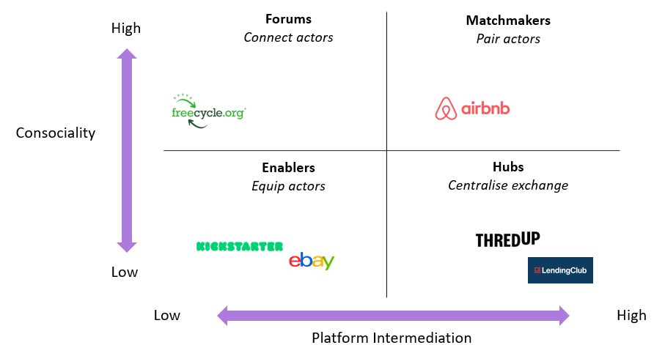  Unit 2 - How to start a business in sharing economy  Section 1: Business idea  To launch a business in sharing economy, it is important to:  “Take the time to look for real problems that need real solutions, problems that can be best solved by communities themselves.” (Buczynski, 2013).  To get inspired these are some potential business ideas that might be adjusted to a particular target group or to a local context.  - Attire buy, sell and swap  - Parking space rental platforms  - Education sharing platforms  - Social eating  - Food delivery, food saving  - Peer-to-peer technology lending service  - Jewellery rental  - Carpooling  - Hub of creative/business activities, co-working platforms  - Freelancing platform  Section 2: How to start  1. First of all, carry out desk research to find out “real problems that need real solutions”.  2. After identifying the business idea, based on your experience and the results of the desk research, Test & Validate your idea.  Case in point:  The founder of the Food Sharing App OLIO (see the Best Practice of this module), validated her idea on a WhatsApp Group, being a quick and low cost solution. She involved a small group of people living close to each other, and asked them for 2 weeks to add any surplus food they had into the group. The result and feedback were very positive and the idea was launched.  5. Once validated, find out for investors willing to support the idea.  If you do not possess the technical skills to design a platform, engage a development agency or professional developers (consider these costs when planning the initial budget).  4. Before the official launch of the product, a minimum viable product version of the platform should be launched so to collect feedbacks from the first users.  5. After the fine-tuning based on the inputs received, the business is ready to start.  Section 3: Supply and Demand  Sharing economy operates through two sided platforms, feeding both supply and demand.  In traditional economy:  - Firms recruit customers and create their own supply;  - Services’ providers are employees of the company.  On the contrary, in sharing economy:  - Firms recruit both customers and providers;  - Providers are not employees.  How to balance supply and demand in sharing economy?  While traditional firms can fire or hire employees, in sharing economy there are alternative strategies:  - Surging prices in a particular area when the demand is high through a specific algorithm;  - Reducing customers willing to pay for services and increasing providers willing to serve.  Section 4: Crowdsource supply  In sharing economy, supply is crowdsourced and suppliers are not employees.  Which are the risks?  - Less control on the suppliers;  - Risk of low quality services.  How to mitigate those risks?  - Careful selection of suppliers (background checks)  - Training and exams  - Rating system (eliminating suppliers with lower rates)  To leverage supply and demand different strategies should be adopted.  Example  A service that allows cars’ owners parking at the airport to rent out their cars to other travelers:  - Secures renters through paid acquisition, such as display advertising or rental search aggregators;  - Builds supply of car owners through public relations, press opportunities or word-of-mouth.  Section 5: Tips & Tricks  1. Foster Trust  Transparency is an essential part of the peer-to-peer world.  Positive online reviews and ratings are indeed crucial for gaining consumer trust.  Case in point:  A Platform for pet sitting, connecting pet owners in need of boarding or sitting services, should foster trust through a 24/7 veterinarian consultations, premium pet insurance or the sharing of photos and videos of sitters interacting with the pets (see Rover).  2. Keep payments simple  The entire process should be paperless and automated. Customers should be able to pay a flat fee through the online platform, while services’ providers should receive wages via PayPal, credit card or check.  3. Brand-building, networking and communication  The sharing economy is about community and communication.  Social media plays an integral role in the construction of the branding and the search for new clients or partners. Do not avoid negative feedbacks or criticism; always engage with them.  Section 6: How to be competitive  Today, there are plenty of sharing services and platforms available.  People choose those services mainly because of lower prices; in order to keep the offer attractive, it is therefore necessary to be competitive in the price positioning.  However, if the final goal is to create innovative solutions, there is much more to be done:  Lack of regulation in sharing economy often results in the exploitation of the suppliers or it negatively affects the traditional economy.  There is an increasing awareness of the “dark sides” of sharing economy; for this reason, people are more and more in search for fairer and sustainable ways of consumption.  New businesses should bring back sharing economy to its original meaning, to the creation and development of:  - Sustainable consumption practices;  - Sense of belonging to a community.  Summing up  - Sharing economy is a new phenomenon that can bring to several opportunities.  - Sharing economy is based on peer-to-peer exchange, the use of digital platforms and sustainability.  - In sharing economy not only costumers but also providers must be recruited. The supply must be crowdsourced, while supply and demand match on the digital platforms.  - Crowdsourcing supply can be risky but there are different strategies to mitigate potential risks.  - Today there are a plenty of sharing platforms. So how to be innovative? Sustainable consumption practices and the sense of belonging to a community are the key.
Glossary | Minimum Viable Product  A Minimum Viable Product (MVP) is a product with enough features to attract early-adopter customers and validate a product idea early in the product development cycle.  MVP is a full-scale test in the real market situation for start-up products; it helps to build an interaction with the target audience and grab potential customers’ attention and fulfill their needs.
Self-evaluation (multiple choice queries and answers) | 1. Which are the features of sharing economy?  a) Collaborative consumption, peer to peer exchange and sustainability  b) Hierarchical relationships between producer and consumer  c) Individual consumption, peer to peer exchange and sustainability  2. Which sentence is true?  a) In traditional economy, firms do not create their own supply  b) In sharing economy, firms recruit both customers and providers  c) In sharing economy, firms hire employees  3. How supply is ensured in shared economy?  a) Through the hiring of employees  b) Supply is crowdsourced through a digital platform  c) Supply is produced by the company  4. How to mitigate the risks of crowdsourcing supply?  a) Recruit as many suppliers as possible  b) Avoid checks on the suppliers  c) Adopt background checks of suppliers, training, exams and rating system  5. How to be competitive and innovative in the sharing economy market?  a) Promoting sustainable consumption practices and the sense of belonging to a community  b) Promoting individualistic habits and practices  c) Keep the prices low at the cost of providers’ exploitation and not sustainable practices
Bibliography | Perren & Kozinets (2018), Lateral Exchange Markets  https://www.semanticscholar.org/paper/Lateral-Exchange-Markets%3A-How-Social-Platforms-in-a-Perren-Kozinets/62b266886e146ec22fbe3e30d95c498a3c1307c3  Buczynski B. (2013), Sharing is good. How to Save Money, Time and Resources through Collaborative Consumption, New society Publishers.  https://www.amazon.com/Sharing-Good-Resources-Collaborative-Consumption/dp/086571746X?asin=086571746X&revisionId=&format=4&depth=1  Heinonen S. & Poutanen W. (2019), Communal sharing helps the environment in rural areas, Circblog (consulted on 2022/11/20)  https://www.circwaste.fi/en-US/Current/Circblog/Communal_sharing_helps_the_environment_i(53663)  Collin P. (2021), The sharing economy: Definition, examples and advantages, Selectrta (consulted on 2022/11/20)  https://climate.selectra.com/en/environment/sharing-economy
Resources (videos, reference link) | Women in Sharing Economy  https://www.benitamatofska.com/single-post/2018/03/06/the-best-place-for-women-is-in-the-sharing-economy  Women Forum for Economy & Society – A sharing economy?  https://www.youtube.com/watch?v=MSGwgBLqUDo&t=797s

